

**St. Augustine**

**Don’t forget…4th and 5th grade students will be participating in a fun-filled, educational field trip to St. Augustine on Monday, May 23rd. Students AND chaperones need to be at school no later than 7:00 that morning, as the bus will be leaving at 7:30 sharp. We should be returning by 6:00 pm.**

**For this field trip, students should wear their red HLA t-shirts (if they have one) and comfortable walking shoes. They should also bring a snack, and plenty of water. A lunch from Subway will be provided, and students already voted on their choice of sandwich. In addition, I would recommend sunscreen, a book or sketchbook for the bus ride, and some cash for exploring the shops on St. George Street.**

***\*Reminder: Permission slips and $$$ are due THIS Friday- NO* *EXCEPTIONS!***

Notes from Ms. Katje**:** There was no music this past week due to FSA testing. Students will continue with percussion instruments this week.

Notes from Coach Cotter**:** No updates provided.

**Citizen of the month**

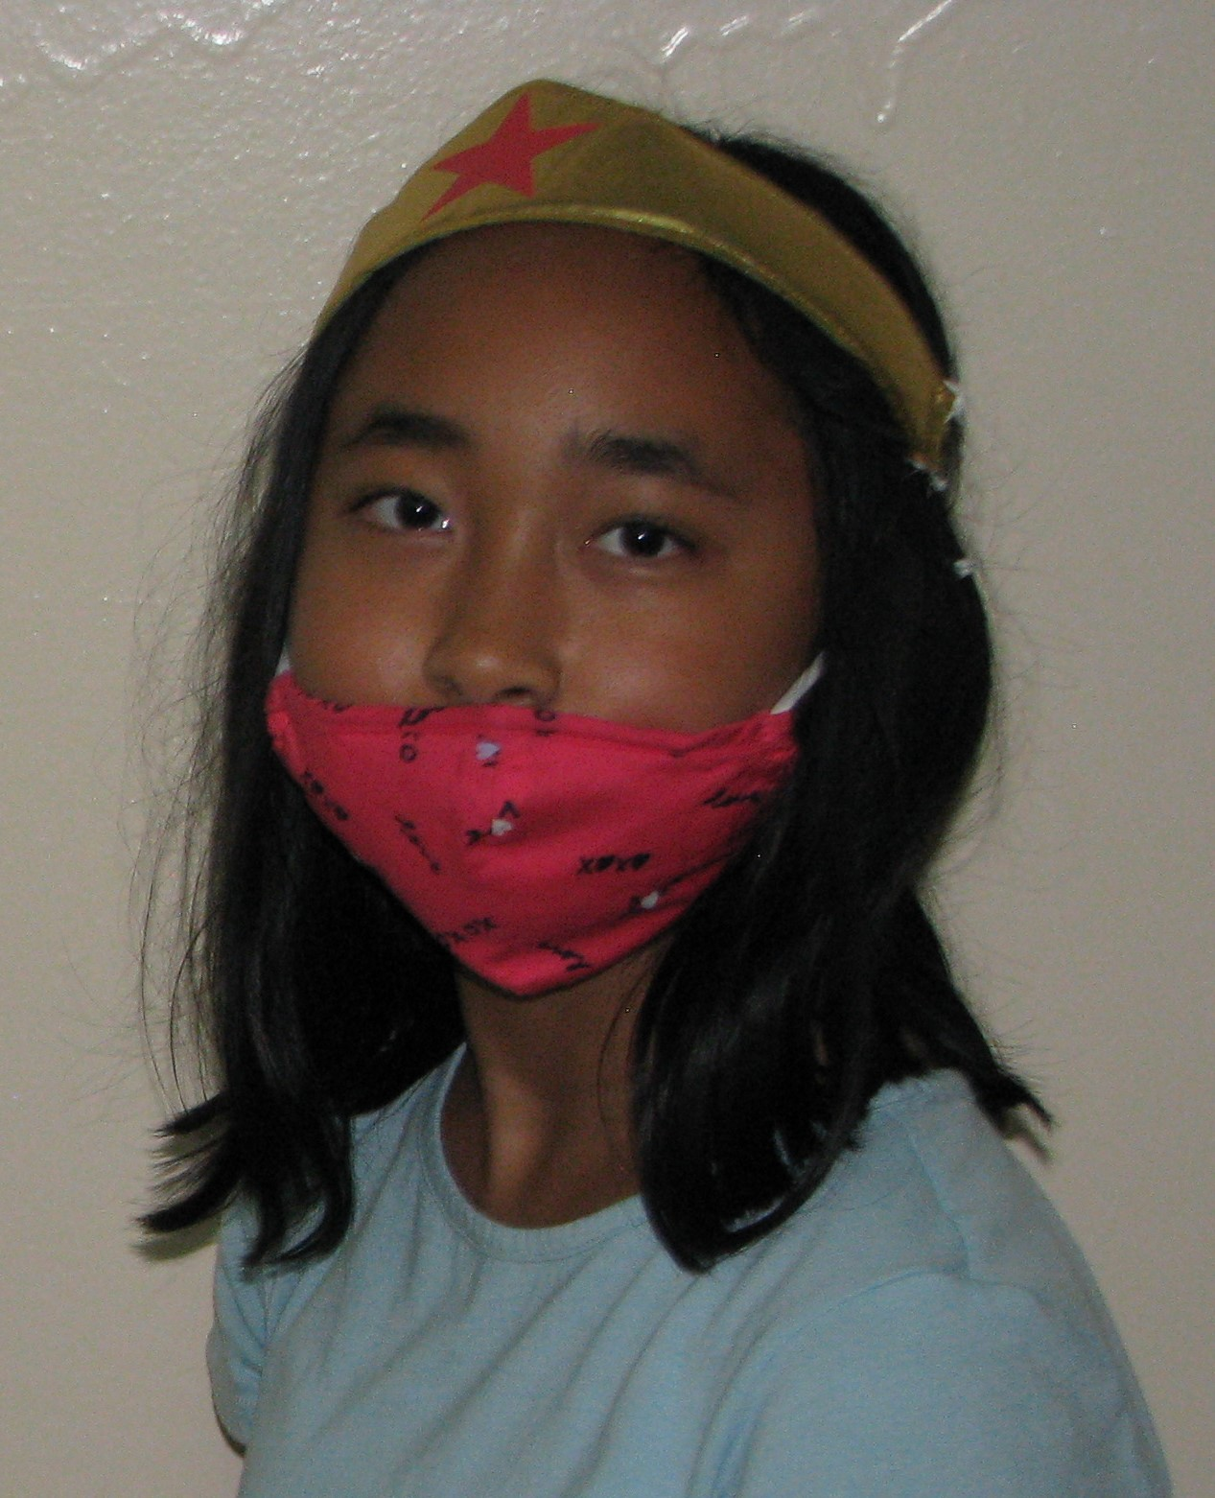

**Congratulations to Lianna Trinos!**

**While there is no spelling homework during Spring Break, the attached reading comprehension and Science Fair activity is due the Friday that we return, April 1st.**

May 6, 2022

**Wednesday, May 11:** Crazy Hair Spirit Day

**Monday, May 16-Tuesday, May 17:** Science FSA

**Wednesday, May 18:** Science Fair projects due, Field Day

**Thursday, May 19:** Science Fair (6-7:00 pm)

**Monday, May 23:** St. Augustine

**Tuesday, May 24:** Spelling Bee

**Wednesday, May 25:** Graduation (8:30-9:30 am)

**Thursday, May 26:** Talent Show

**Friday, May 27:** Last day of school

|  |
| --- |
| In between the ELA and Math FSA tests, students were able to continue to review for the FSA, as well as do science and social studies.  In science, we just tested on Unit 10: Changes in Environments, and are currently studying Unit 11: Plant and Animal Adaptations. Students have a Science FSA study guide, and should be reviewing at home!  We’re still studying the American Revolution in social studies. |
| **Word of the Week:**  Our word of the week was “sincerity,” which is the quality of being open, honest, and genuine. People who are perceived as being sincere in their manner and words generally have an easier time getting others to believe in them and to trust ideas or plans they want to implement. |
|  |

### Students should neatly write and mark each of the following words with large, legible print on the index cards sent home today. This week, we will focus on commonly misspelled words.

### tragedy beneficial grateful weigh quiet

### quite truly calendar receive changeable

#### Spelling

#### Miscellaneous

#### The Week In Review

THE

BECKER BULLETIN