**Thank you!**

**I just wanted to thank everyone for making the first two weeks of the 2021-22 school year so wonderful. I’m thrilled to have your children in my class, and I know that we’re going to have an amazing year. Your help with supplies, routines, and returning paperwork has been greatly appreciated.**

**I also want to thank everyone who attended yesterday’s “Open House” using Google Meet. I realize that I provided you with a lot of information, but please don’t let it cause you any anxiety. Things like Grade Level Expectations (GLEs) can be overwhelming to look at. However, those are the things that I need to focus on…not you. If you would like to help your child, check their planner each day to make sure that their homework has been completed. In addition, listen to them read 15-20 minutes each evening. Finally, invest in flash cards. It is ESSENTIAL that students know their multiplication tables this year! Thanks for all of your support!**

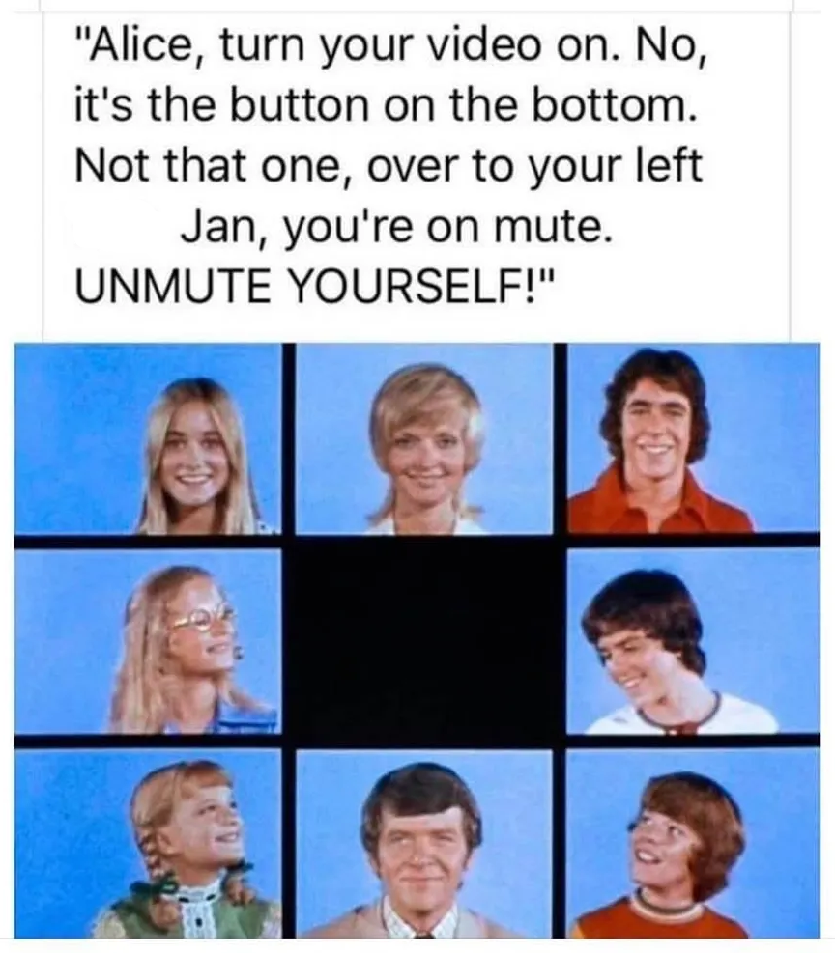

**The Wheel**

**Here are our Wheel activities for the upcoming week:**

**Monday- Orange (SEL)\***

**Tuesday- Yellow (Study Hall)\*\***

**Thursday- Green (Spanish)**

**Friday- Blue (Garden/Cooking)**

***\*SEL = social emotional learning***

***\*\*Study Hall (yellow and purple days) will be used for SS and science instruction***

**Water Bottles**

**Because of the amount of physical activity we do during the day, and because of the research on how hydration helps our brains, it is imperative that students bring a fresh bottle of water to school each day.**

Notes from Ms. Katje**:** Students have discussed procedures and art goals for the year, and after a review on color mixing, began to make characters with model magic.

Notes from Coach Cotter**:** This week we are continuing to reinforce the policies and procedures we went over last week. We are also beginning to work on fundamental athletic skills which we will continue to build on in the next couple of weeks as we transition to our core sports units.

|  |
| --- |
| **This past week, we participated in yoga, discussed classroom rules and procedures, practiced highlighting skills, learned about text features, and took our beginning of the year tests in ELA, math, science, and writing. In addition, we developed teamwork skills by working on a straw tower STEAM project. Overall, it was a good and productive week! This upcoming week, we will begin our regular homework routine in spelling and math.** |
| **Word of the Week:**  **Our word of the week was “responsibility.” Being responsible means that one is held accountable for his/her actions, is trustworthy, and can be counted upon to do the right thing. To become a member of our Safety Patrol, I look for responsible students that I can trust to help others and make good decisions.** |
|  |

August 20, 2021

#### Spelling

### **Students should neatly write and mark each of the following words with large, legible print on the index cards sent home today.** **This week, we will focus on long vowel sounds.**

**ovation notation probation citation elation**

**facial mutation glacial dilation spatial**

#### Miscellaneous

#### The Week In Review

THE

BECKER BULLETIN