Matts Memos
November 18th – 22nd, 2019

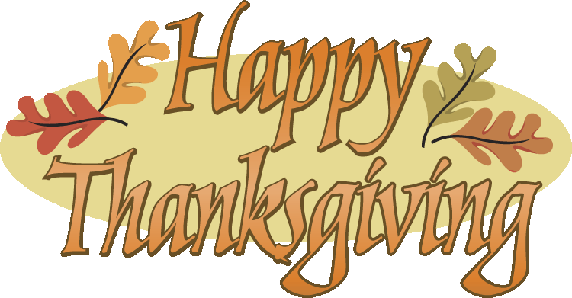

*Reminders –
Wednesday, November 20th – Thanksgiving Luncheon (still could use dishes )
Wednesday, November 20th & Thursday, November 21st- Mid Year Math Test
Thursday, November 21st – Progress Reports coming home
Thursday, November 21st – PI Night (please come in and help us cook )
Monday, November 25th – Friday, November 29th – No School Thanksgiving Break

**Spelling Words- I will hand out a newsletter with the spelling words on Monday, December 2nd. The spelling test will be on Friday, December 6th and 16 points will be needed for the Matts Menu.

***Reading Logs and math practice- The OPTIONAL reading log and summary will be due Monday December 2nd. Please be sure your child is working on his/her summaries as they finish reading a selection. Do not forget to read over the Thanksgiving break! If the reading log and summary is completed over the break extra Matts Cash will be given. A new reading log will be handed out upon the children’s return to school and due the following Friday.

****Math Practice- It is very important that you are continuing to practice the math flashcards or activities at home (division, multiplication, addition, and subtraction)! Please continue to practice these skills over the holiday. Do not forget to fill out the math log that is located in your children’s purple folder. Please be sure to mix up multiplication, addition, and subtraction facts so we aren’t forgetting those other important facts. The Math log will be due Monday, December 2nd.

*****School Days – Please be sure to ask your children about the following activities from this past week: completing our reading story, completing chapter 9 in math, the word of the week – patience, learning our songs we will sing in the program, and what is going on in PE, Art (we switched over to music to help learn our songs for the program), and Morning Meeting.

****** Tip of the week- The weather is getting nicer, and we will soon have an entire week off from school. Be sure to get out and move with your child over the break. Family outdoor games are a great way to promote fun and a healthy family.

OVER

Spelling List

(contractions- students will need to spell and punctuate the contraction correctly and know what it stands for)

wouldn’t – would not won’t – will not
mustn’t – must not weren’t – were not
who’s – who is/ has that’ll – that will
they’d – they would shan’t – shall not shouldn’t – should not you’ve – you have

**This section is for you! Please feel free to write any questions/comments/concerns you may have for me in this space. Please sign and return so I’ll know you have read this newsletter.
_____________________________________________________________________________
_____________________________________________________________________________
Signature______________________________________________________________________

