**Thank You, Parents!**

**As Teacher Appreciation draws to a close, I just wanted to thank all my parents who contributed to this special week. Whether you provided breakfast or lunch, helped to decorate, or provided the very generous gift cards, I hope you realize just how much my co-workers and I appreciated it. In addition, I wanted to thank Mr. Clark, Mrs. Mahmood, Mrs. Moore, and Mrs. Smith for chaperoning our St. Augustine trip. The kids had a great time and were very well-behaved, and a large part of that is due to you. I hope you enjoyed yourselves as much as we enjoyed having you with us!**

**Graduation**

**Graduation will be Wednesday, May 29th, from 11-12. We will have a brief ceremony followed by a small party. Contact Anisah Mahmood at** [**anisahmahmood@gmail.com**](mailto:anisahmahmood@gmail.com) **to see how you can help!**

### **For Monday, students should neatly write and mark each of the following words with large, legible print on the index cards sent home today.**

**kiln watermelon apologize tedious knead**

**English skewer ardor traverse jostle**

### 

|  |
| --- |
| **SS: We’ve been learning about the Constitution and Bill of Rights, and will probably test sometime next week.**  **ELA: This week, we did spelling and vocab, and focused on the suffixes, “-ance” and “-ence.”**  **Math: We studied geometry before the FSA, but just reviewed and tested the chapter this past week.**  **Science: We just tested Ch. 8, which we studied before the FSA. Many students did very well!** |
| **Word of the Week:**  **Our word of the week was “accomplishment.” It is rightly said that the way to check how productive someone's life is, is by knowing his life accomplishments. Our accomplishments serve as a proof of the work that we put in towards the achievement of a certain goal.** |
|  |

**Citizen of the Week**

**Congratulations to Jade Malone-Taylor!**

**Camp Kulaqua**

**Our field trip to Camp Kulaqua will be this Thursday, May 23rd. Students should bring a lunch, towel, and change of clothes. In addition, you may want to send water and sunscreen. No money is necessary. Please make arrangements to be at HLA to pick up your child at 2:30.**

**Class Auction**

**I’d love to have one last class auction before the end of the year. If you have any old toys, books, etc. lying around the house, I’d greatly appreciate some donations!**

**May 17, 2018**

---------------------------------------------------------------------------------------------------------------------------------------------

I have read the May 17 edition of *The Becker Bulletin*

Student Signature ______________________________ Parent Signature ________________________________

Questions/Comments ____________________________________________________________________________________________________________________________________________________________________________________________________________________________________________________________

#### Spelling

#### Miscellaneous

#### The Week In Review

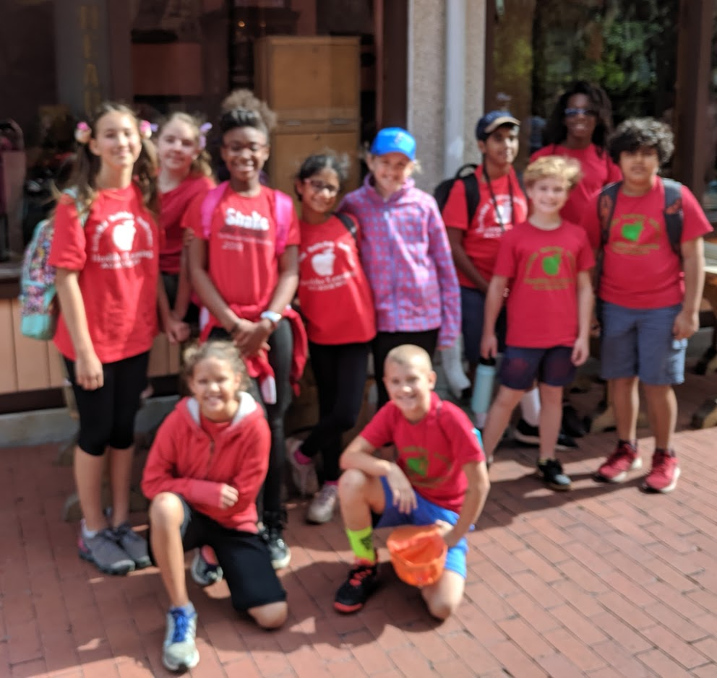

THE

BECKER BULLETIN