**Parent Involvement Night**

**Our final Parent Involvement Night will be this Thursday, May 24th. Come and join us as students will be presenting their “Living Museum” projects. Students should come dressed as their historical figure, and present their research “in character.” It should be a fun-filled, educational evening. Please remember that this is a graded assignment, and students will also be presenting that day in-class.**

**If any parents still need volunteer hours, we’d love some help cooking Thursday afternoon from 12:45-1:45. We recently harvested our potatoes, so I’ll be searching for a good recipe that we can share that evening. Email me if you can help!**

**Class Auction**

**I’d love to have one last class auction before the end of the year. If you have any old toys, books, etc. lying around the house, I’d greatly appreciate some donations!**

### **For Monday, students should neatly write and mark each of the following words with large, legible print on the index cards sent home today.**

**kiln watermelon apologize tedious knead**

**English skewer ardor traverse jostle**

### 

|  |
| --- |
| **SS: We just tested on the American Revolution!**  **ELA: We continued our class novel, Sign of the Beaver, did spelling, and focused on the suffixes, “-ance” and “-ence.”**  **Math: We studied measurement before the FSA, but just reviewed and tested the chapter this past week. We’ll do the same with geometry.**  **Science: We’ve taken a break from science to catch up on other things. I’m still hoping to get in an experiment or two, though!** |
| **Word of the Week:**  **Our word of the week was “indomitable spirit.” Someone with an indomitable spirit is unyielding or unconquerable. They refuse to give up, no matter the task. Even if they fail, they will continue to endure until they find success. All of our students should have an indomitable spirit and persevere!** |
|  |

**Parent Surveys**

**Parent surveys were sent home via email last week, and will need to be completed by Wednesday, May 23rd. Please put some time and effort into these surveys so we can see what we’re doing well, and what we need to improve upon. If you would like a paper copy, please contact Mrs. Carr.**

**Graduation**

**Graduation will be Tuesday, May 29th, from 1-2. We will have a brief ceremony where students and faculty will give speeches, and then we’ll have cake! A special thanks to Mrs. Wonders who will be ordering the cake!**

**May 18, 2018**

---------------------------------------------------------------------------------------------------------------------------------------------

I have read the May 18 edition of *The Becker Bulletin*

Student Signature ______________________________ Parent Signature ________________________________

Questions/Comments ____________________________________________________________________________________________________________________________________________________________________________________________________________________________________________________________

#### Spelling

#### Miscellaneous

#### The Week In Review

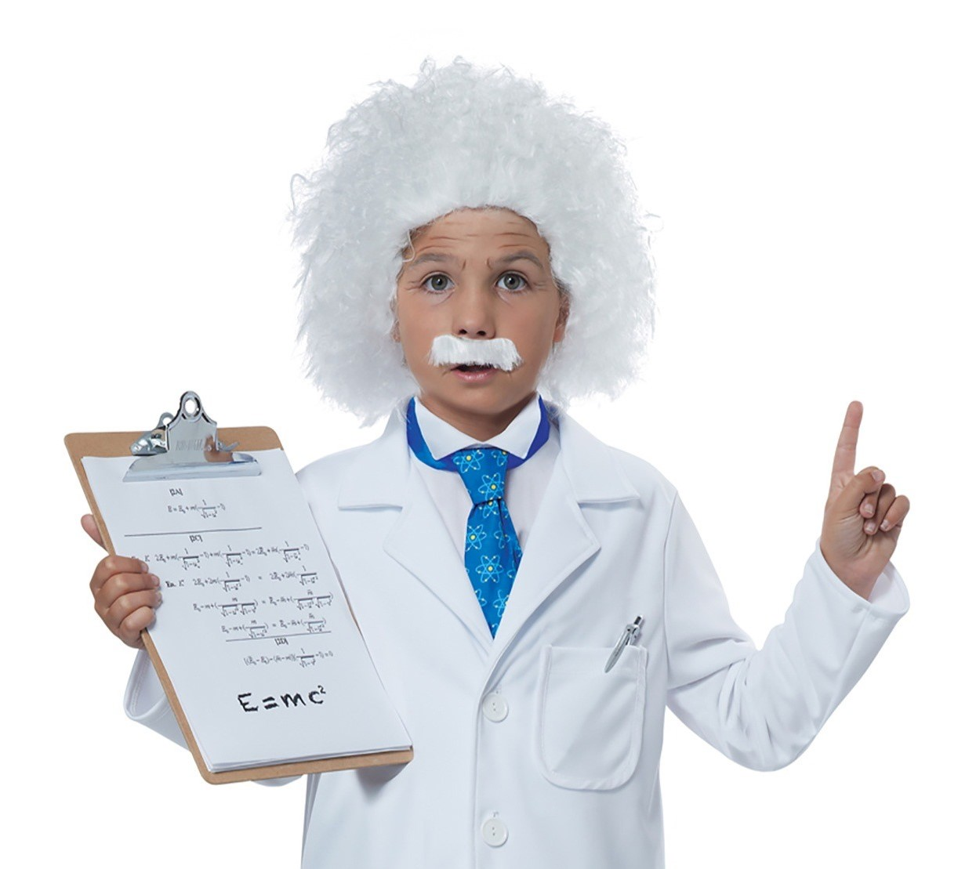

THE

BECKER BULLETIN