Matts Memos
November 20th – 24th, 2017
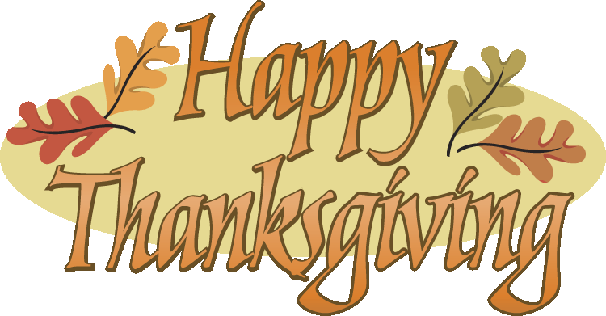

*No School Reminder- This is just another reminder that there will be no school the week of November 20th – 24th for the Thanksgiving Break. School will resume on Monday, November 27th. Have a wonderful Thanksgiving Break!

**Spelling Words- I will hand out a newsletter with the spelling words on Monday, November, 27th. The spelling test will be on Friday, December 1st and 16 points will be needed for the Matts Menu.

***Reading Logs and math practice- The OPTIONAL reading log and summary will be due Monday November 27^{th,} along with the OPTIONAL math fluency practice pages. Please be sure your child is working on his/her summaries as they finish reading a selection. Do not forget to read over the Thanksgiving break! If the reading log and summary is completed over the break along with the fluency practice pages, $100 in Matts Cash will be given. A new reading log will be handed out upon the children’s return to school and due the following Friday.

****Math Flashcards- It is very important that you are continuing to practice the math flashcards or activities at home (division, multiplication, addition, and subtraction)! Please continue to practice these skills over the holiday. Do not forget to fill out the math log that is located in your children’s purple folder. Please be sure to mix up multiplication, addition, and subtraction facts that we discussed at conferences. The Math log will be due Wednesday, November 30th.

*****School Days – Please be sure to ask your children about the following activities from this past week: our challenging math lesson on Monday, completing chapter 6 in math, the word of the week – gratitude, learning our songs we will sing in the program, and what is going on in PE, Music, and Morning Meeting.

****** Tip of the week- The weather is getting nicer, and we have an entire week off from school. Be sure to get out and move with your child over the break. Family outdoor games are a great way to promote fun and a healthy family.

Spelling List

Please review the words we have had thus far with your children. It is very important that they keep these rules fresh in their minds.
__________________________________________________________________

**This section is for you! Please feel free to write any questions/comments/concerns you may have for me in this space. Please sign and return so I’ll know you have read this newsletter.
_____________________________________________________________________________
_____________________________________________________________________________
Signature______________________________________________________________________

