**Pumpkin Day**

**Pumpkin Day will be held on Tuesday, October 31, from 8:00 am until noon. Students will participate in a fun, yet educational day filled with activities that encompass such subjects as math, language arts, science, art, and physical education.**

**Each student will need to bring in a small pumpkin for the festivities. S/he will be responsible for carrying the pumpkin from one station to another, so don’t purchase anything too heavy or cumbersome! Pumpkins need to have the student’s name and the cost written on the bottom. Please DO NOT cut a lid on the pumpkin or slice it open in any way. The pumpkin will come home at the end of the day and can be used for family fun in any way that you wish. This would be a great volunteer opportunity, so please let me know if you’re interested, or visit the Sign-Up Genius on the HLA website.**

**After lunch, I plan to have my “Fall Festival” party. Any food or drinks that you could contribute would be greatly appreciated by me, as well as my scholars!**

**October 19, 2017**

|  |
| --- |
| **SS: We’re learning about civics and government, and how to highlight effectively.**  **ELA: This week, we covered characters, direct and indirect objects, and the prefix, “bi-.”**  **Math: We’ve been working in Ch. 2 and studying prime factorization and exponents. Students are beginning to see the importance of knowing their multiplication facts!**  **Science: We’re still on Ch. 1, but students are learning how to take notes. It’s a slow process, but it will pay off!** |
| **Word of the Week:**  **Our word of the week was “acceptance.” Acceptance is empowering, and practicing it can help heal you and improve your life. Don’t weigh yourself down with the challenges life throws at you…accept them, learn from them, and move on!** |
|  |

### Students should neatly write each of the following words with large, legible print on the index cards sent home today. In addition, they need to mark consonants, vowels, and syllable breaks. We will do all the remaining marking of the words in class on Monday.

charcoal loathing encroaching reproachful boastfulness

furrowed shallow billowy overthrow bellowed

---------------------------------------------------------------------------------------------------------------------------------------------

I have read the October 19 edition of *The Becker Bulletin*

Student Signature ______________________________ Parent Signature ________________________________

Questions/Comments ____________________________________________________________________________________________________________________________________________________________________________________________________________________________________________________________

#### Spelling

**Field Trip**

**On Tuesday, 4th and 5th graders visited the Philips Center to witness the musical stylings of Nobuntu, an all-female a cappella ensemble from Zimbabwe. The singers did a great job engaging the students, and spoke of love, unity, and family. It was a remarkable show, and I was extremely proud of how our students represented themselves.**

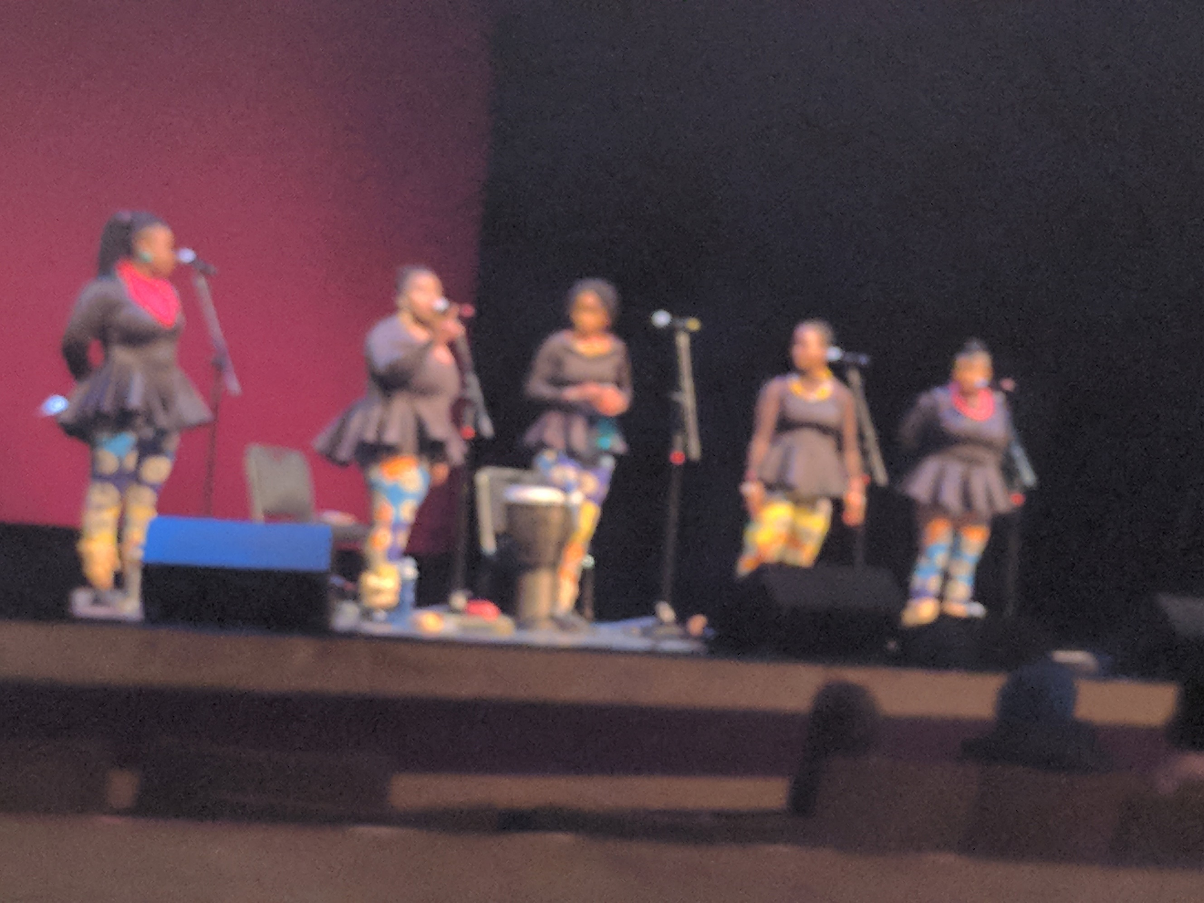

#### Miscellaneous

#### The Week In Review

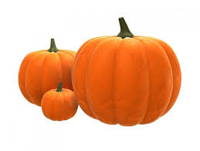

THE

BECKER BULLETIN